TASK 1:
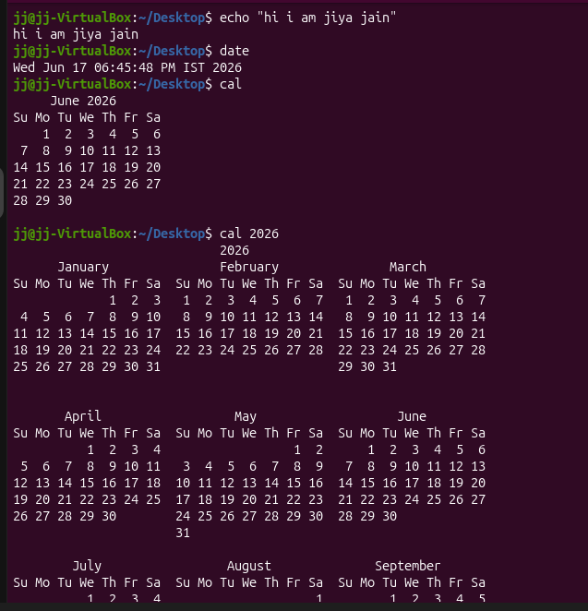
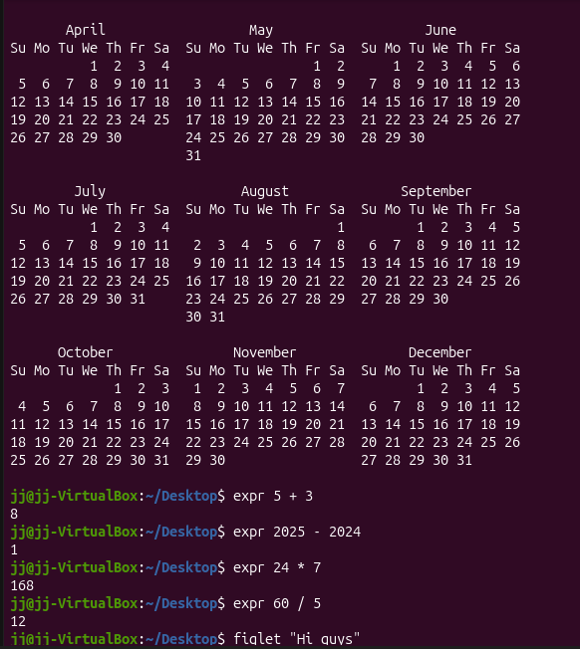
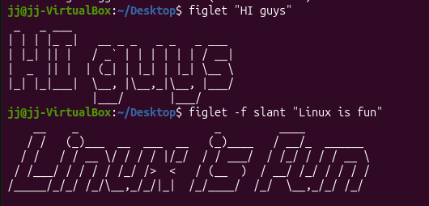
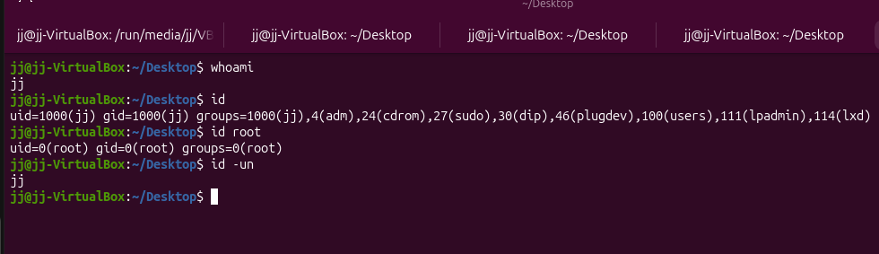
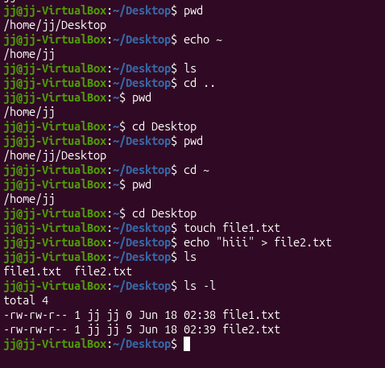
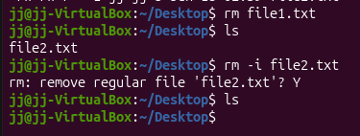
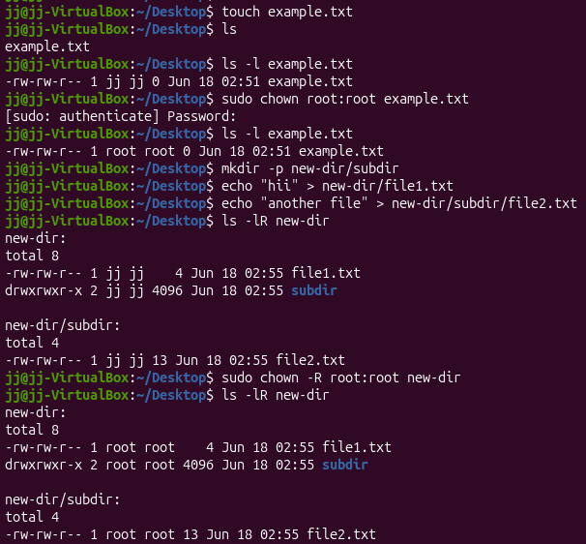

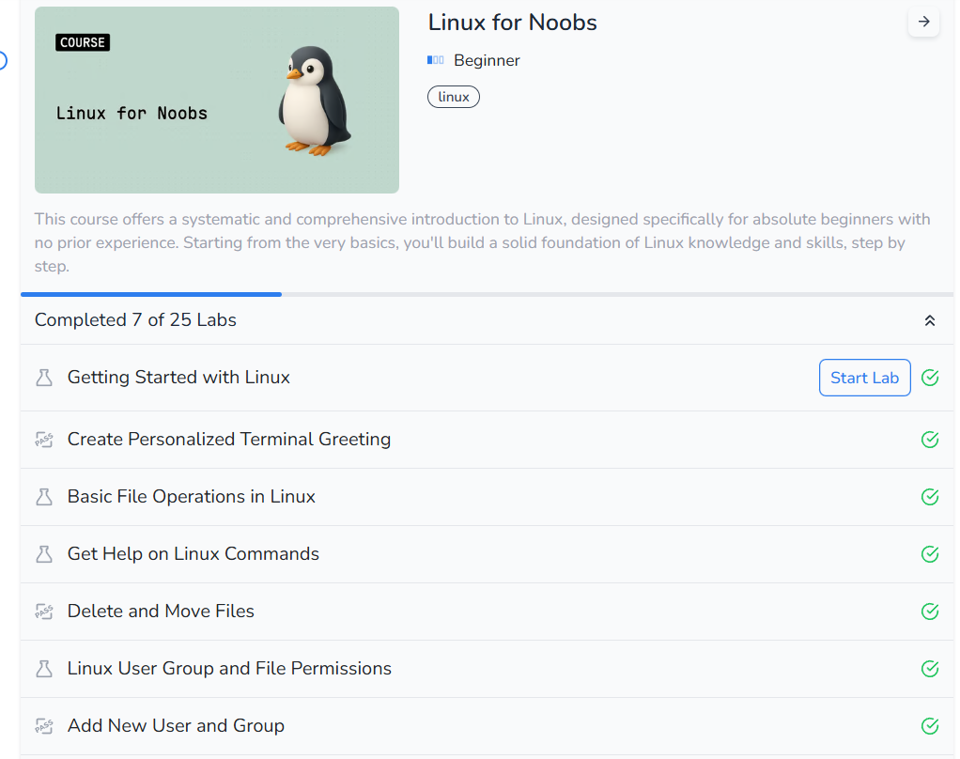
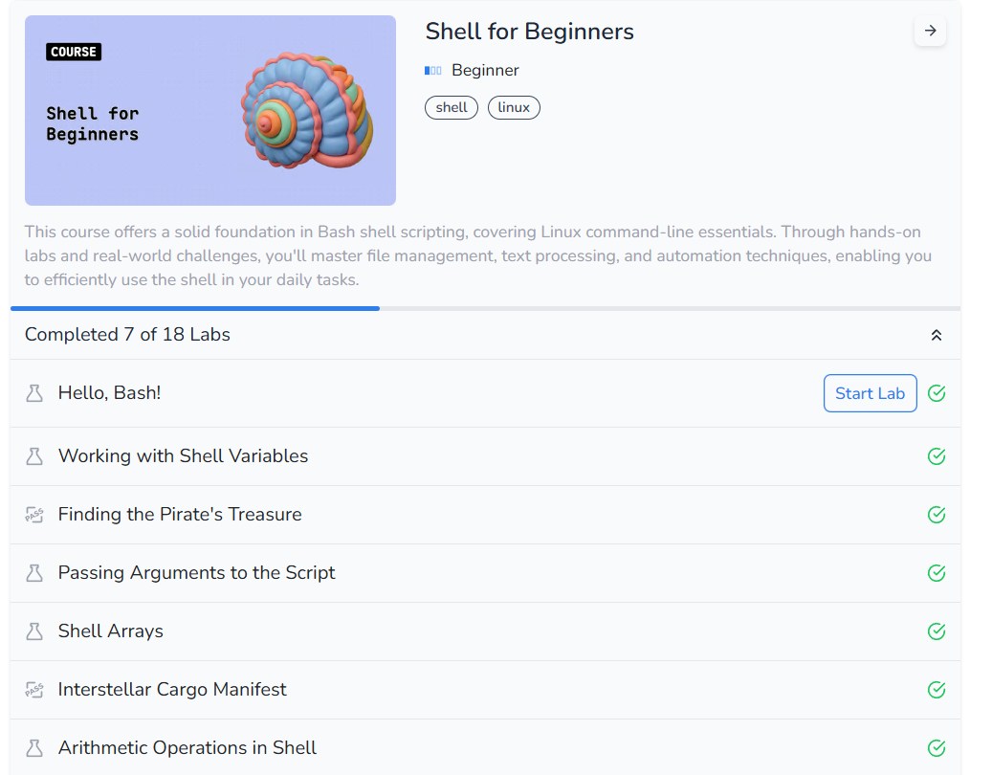

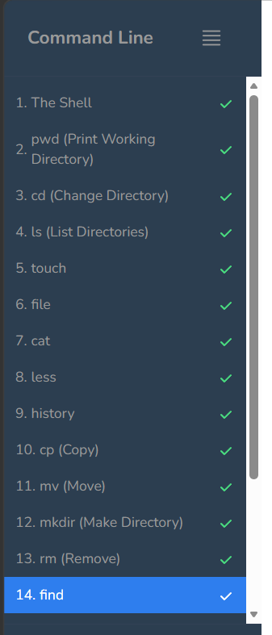
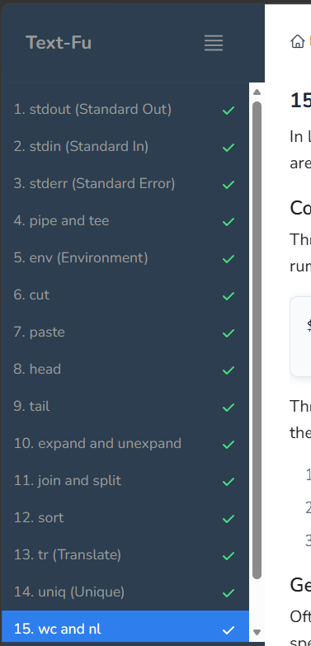
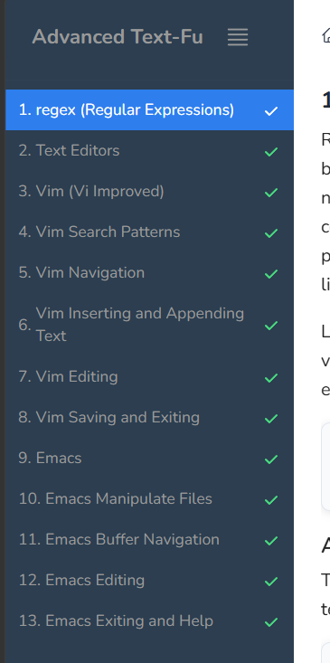

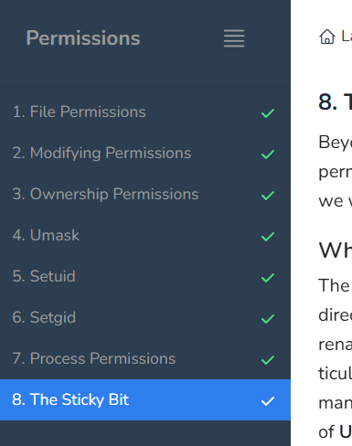
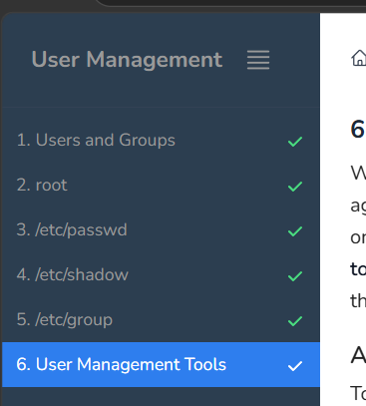
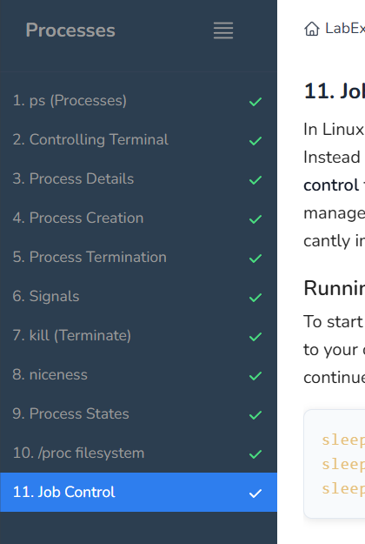
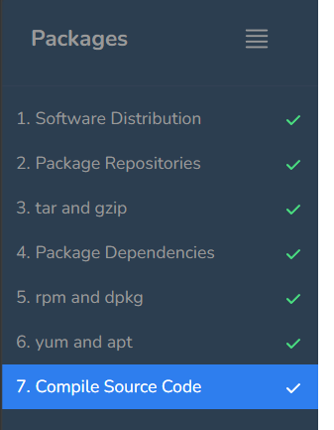

Task 2:
Level 0: ssh bandit0@bandit.labs.overthewire.org -p 2220
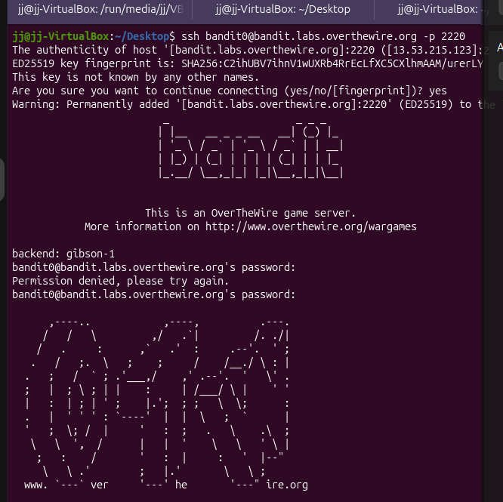
Level 0-1: Password found: ZjLjTmM6FvvyRnrb2rfNWOZOTa6ip5If
Level 1-2: Password found: 263JGJPfgU6LtdEvgfWU1XP5yac29mFx
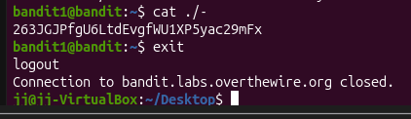
Level 2-3: Password found: MNk8KNH3Usiio41PRUEoDFPqfxLPlSmx
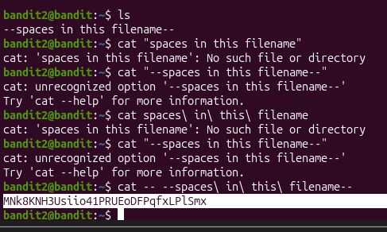
Level 3-4: password found: 2WmrDFRmJIq3IPxneAaMGhap0pFhF3NJ
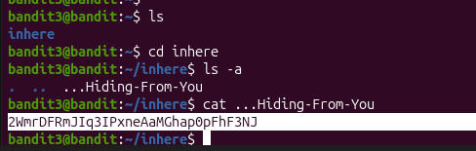
Level 4-5: password found: 4oQYVPkxZOOEOO5pTW81FB8j8lxXGUQw
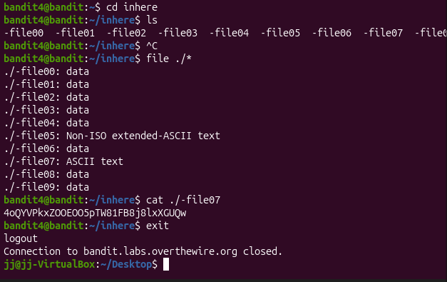
Level 5-6: password found: HWasnPhtq9AVKe0dmk45nxy20cvUa6EG
Level 6-7: password found: morbNTDkSW6jIlUc0ymOdMaLnOlFVAaj
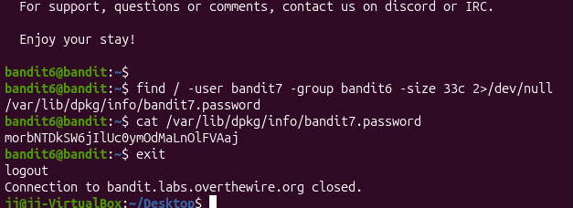
Level 7-8: password found: dfwvzFQi4mU0wfNbFOe9RoWskMLg7eEc
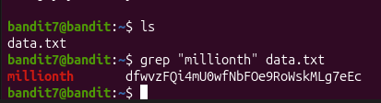
Level 8-9: password found: 4CKMh1JI91bUIZZPXDqGanal4xvAg0JM
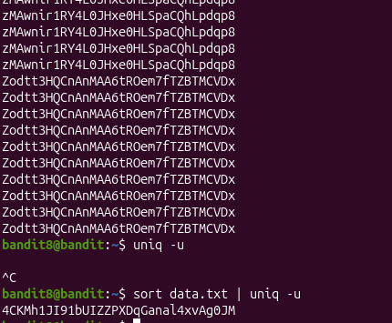
Level 9-10: password found: FGUW5ilLVJrxX9kMYMmlN4MgbpfMiqey
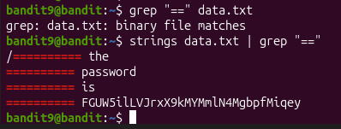
Level 10-11: password found: dtR173fZKb0RRsDFSGsg2RWnpNVj3qRr
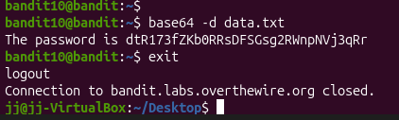
Level 11-12: password found: 7x16WNeHIi5YkIhWsfFIqoognUTyj9Q4
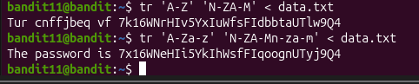

Level 12-13: password found: FO5dwFsc0cbaIiH0h8J2eUks2vdTDwAn
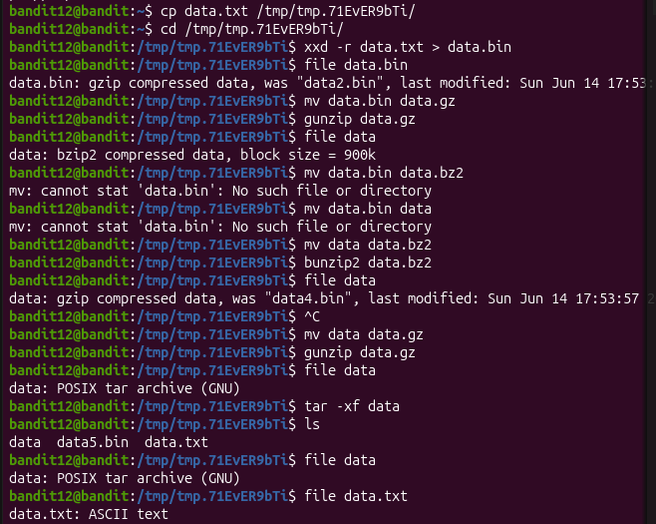
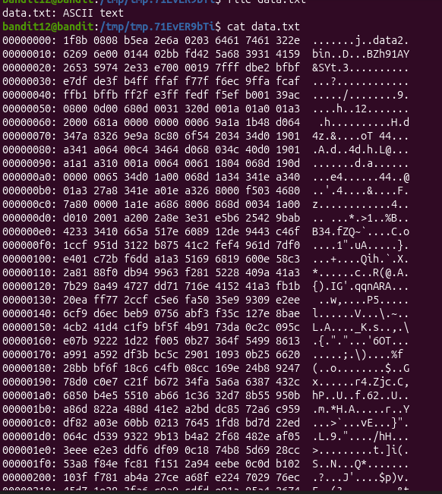
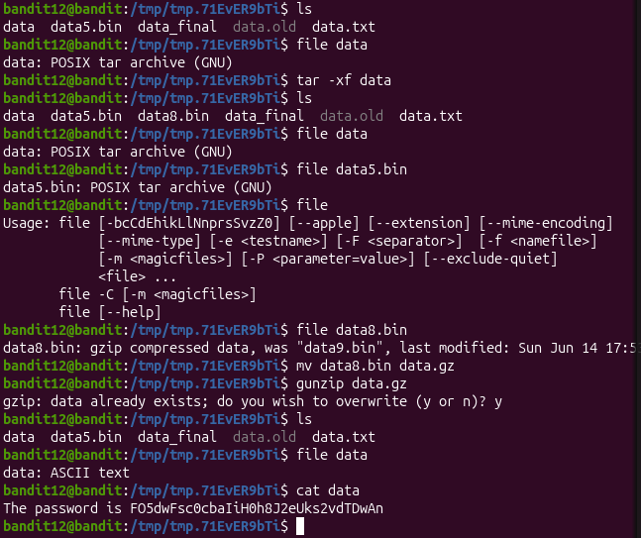
Level 13-14: password found: RSA key, no password
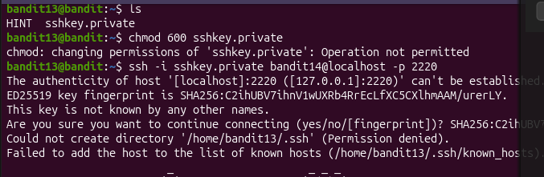
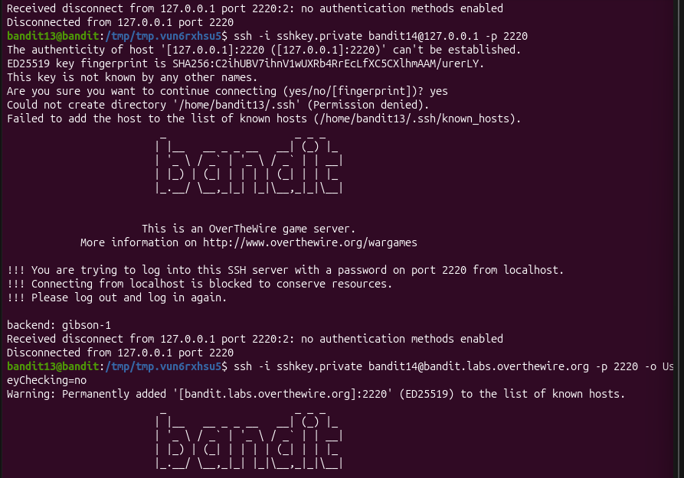
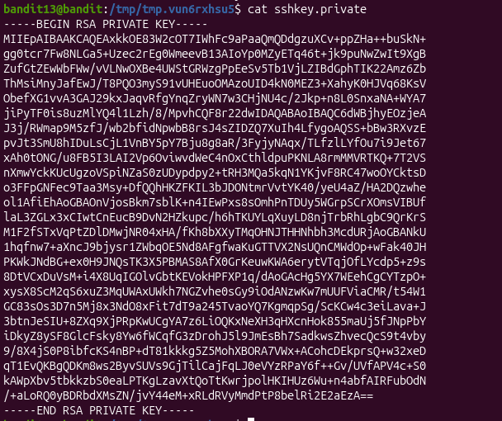
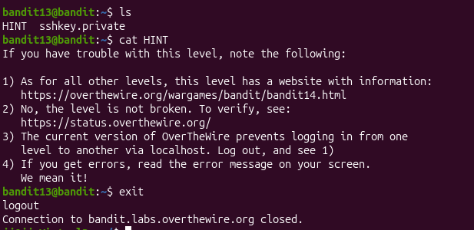
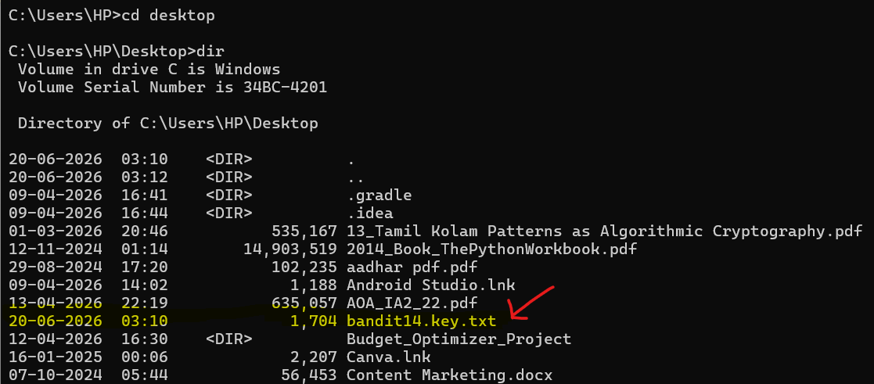
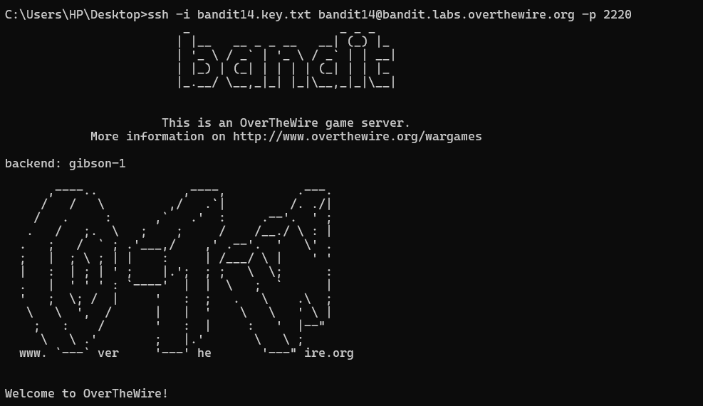
Level 14-15: password found: MU4VWeTyJk8ROof1qqmcBPaLh7lDCPvS
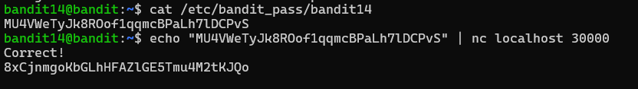
Level 15-16: password found: 8xCjnmgoKbGLhHFAZlGE5Tmu4M2tKJQo

